

**Western Australian Certificate of Education**

**ATAR course examination, 2020**

**Question/Answer Booklet**

12 PHYSICS

Name

**Test 3 - Electromagnetism**

|  |  |  |  |  |  |  |  |  |  |  |
| --- | --- | --- | --- | --- | --- | --- | --- | --- | --- | --- |
| Student Number: In figures |  |  |  |  |  |  |  |  |  |  |

**Mark: $\frac{}{\text{41}}$**  In words

#### Time allowed for this paper

Reading time before commencing work: five minutes

Working time for paper: fifty minutes

**Materials required/recommended for this paper**

To be provided by the supervisor

This Question/Answer Booklet

Formulae and Data Booklet

***To be provided by the candidate***

Standard items: pens, (blue/black preferred), pencils (including coloured), sharpener, correction fluid/tape, eraser, ruler, highlighters

Special items: non-programmable calculators satisfying the conditions set by the School Curriculum and Standards Authority for this course

**Important note to candidates**

No other items may be taken into the examination room. It is your responsibility to ensure that you do not have any unauthorised notes or other items of a non-personal nature in the examination room. If you have any unauthorised material with you, hand it to the supervisor before reading any further.

**Structure of this paper**

|  |  |  |  |  |  |
| --- | --- | --- | --- | --- | --- |
| Section | Number of questions available | Number of questions to be answered | Suggested working time  (minutes) | Marks available | Percentage of exam |
| Section One:  Short Answers | - | - | - |  |  |
| Section Two:  Problem-solving | 6 | 6 | 50 | 41 | 100 |
| Section Three:  Comprehension | - | - | - | - | - |
|  |  |  |  | **Total** | 100 |

**Instructions to candidates**

1. The rules for the conduct of examinations at Holy Cross College are detailed in the College Examination Policy*.* Sitting this examination implies that you agree to abide by these rules.

2. Write your answers in this Question/Answer Booklet.

3. Working or reasoning should be clearly shown when calculating or estimating answers.

4. You must be careful to confine your responses to the specific questions asked and to follow any instructions that are specific to a particular question.

5. Spare pages are included at the end of this booklet. They can be used for planning your

responses and/or as additional space if required to continue an answer.

• Planning: If you use the spare pages for planning, indicate this clearly at the top of the page.

• Continuing an answer: If you need to use the space to continue an answer, indicate in the original answer space where the answer is continued, i.e. give the page number. Fill in the number of the question(s) that you are continuing to answer at the top of the page.

6. Answers to questions involving calculations should be ***evaluated and given in decimal***

***form*.** It is suggested that you quote all answers to ***three significant figures***, with the

exception of questions for which estimates are required. Despite an incorrect final result, credit may be obtained for method and working, providing these are ***clearly and legibly set out***.

7. Questions containing the instruction "estimate" may give insufficient numerical data for their solution. Students should provide appropriate figures to enable an approximate solution to be obtained. Give final answers to a maximum of two significant figures and include appropriate units where applicable.

8. Note that when an answer is a vector quantity, it must be given with magnitude and direction.

9. In all calculations, units must be consistent throughout your working.

1. Draw the field (magnetic or electric) associated with the following. (8 marks)

(a) The Earth. (b) A current-carrying wire in a magnetic field.



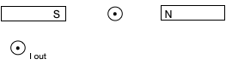

(c) A solenoid. (d) Point charge near a charged plate.

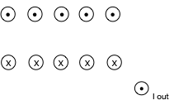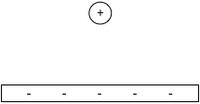

2. Two small spheres, each of mass 5.00 g, are supported from the same point by a light insulating thread 0.500 m long. When they are given equal charges, they repel each other so that the distance between is 80.0 mm. Determine the charge on each sphere.

(6 marks)

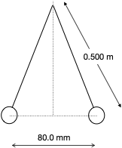

3. A small plastic sphere of mass 2.90 x 10-8 g, when introduced midway between two parallel plates 4.91 mm apart with a potential difference of 285 V across them, is found to "float". Calculate the magnitude and nature of the charge on the sphere, given the top plate is negative. (5 marks)

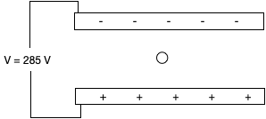

4. A proton enters a uniform magnetic field of 4.50 x 10-4 T directed vertically upward and moves in a horizontal circle of radius 0.633 m.

(a) In which direction (clockwise or anticlockwise) does the proton move? (1 mark)

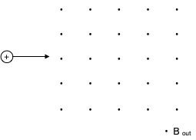

(b) Determine the period of revolution of the proton. (4 marks)

5. A small rectangular coil 3.00 cm x 1.00 cm consists of 500 turns and is suspended in a uniform magnetic field of 0.400 T. The plane of the coil makes an angle of 30.0° to the field and the long side is at right angles to the field. A direct current of 12.0 mA flows in the coil.

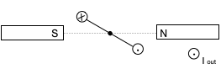

(a) Find the force exerted on the long side of the coil. (3 marks)

(b) What is the maximum torque operating on the coil? (2 marks)

(c) Describe the type of commutator required to keep the coil rotating in one direction and explain why it is necessary. (2 marks)

6. A proton is accelerated from rest in a particle accelerator by a potential difference of 2.50 kV. It then enters the region between two horizontal plates that are 4.00 cm apart, 5.00 cm long and with a potential of 5.00 x 102 V across them. The proton enters down the axis between the plates, equidistant from each.

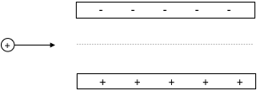

(a) Calculate the horizontal velocity of the proton as it enters the field between the plates.

(3 marks)

(b) Determine the vertical displacement of the proton as a result of travelling between the plates. (7 marks)